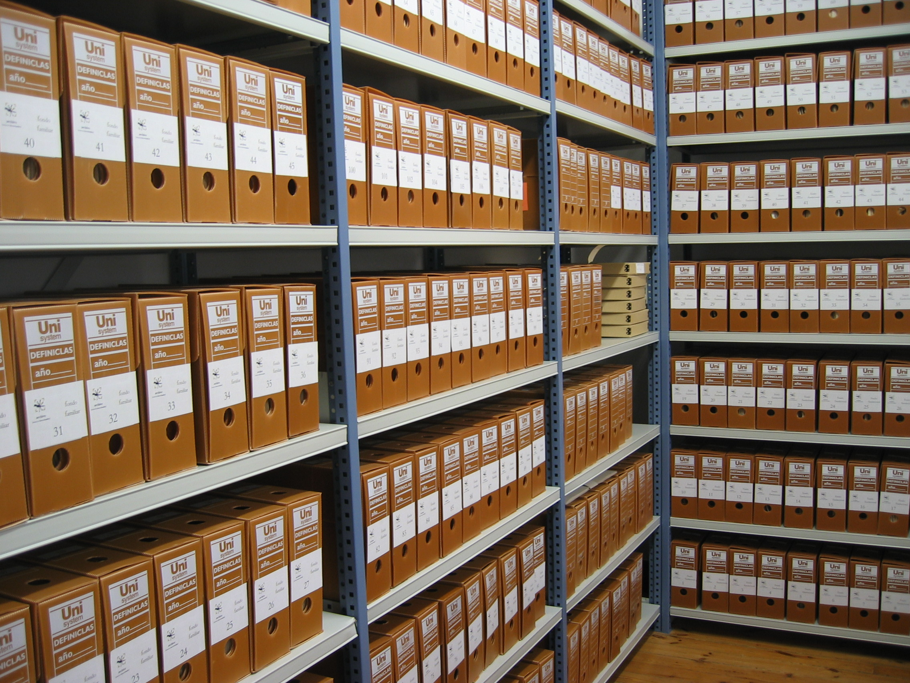
This archive holds more secrets than you can imagine. There are some images hidden from the eyesight, there is much more to unpack here. Can you uncover the secret message?

